HEART DIEASEAS ANALYSIS USING TABLEAU


PROJECT MEMBER NAME:
- Pranav Chavre
- Pranav Jadhav
- Prathamesh Shinde
- Pritam Ghatage

INTODUCTION

Heart disease is one of the leading causes of death worldwide and continues to affect millions of people every year. Rapid lifestyle changes, unhealthy eating habits, increasing stress levels, lack of physical activity, and smoking have
significantly contributed to the growing number of heart disease cases. Although medical science has made great progress in diagnosing and treating cardiovascular diseases, prevention and early detection remain the most
effective ways to reduce mortality and improve quality of life.
In the modern digital era, large amounts of healthcare data are generated from hospitals, clinics, and research institutions. This data includes patient
demographics, medical history, laboratory results, and lifestyle information.
However, analyzing such large datasets using traditional methods is often
difficult and time-consuming. Therefore, advanced data visualization tools are required to convert raw data into meaningful insights that help medical professionals and policymakers make informed decisions.
This project focuses on analyzing heart disease data using Tableau, a powerful business intelligence and data visualization tool. Tableau enables users to create interactive dashboards, charts, and reports that simplify complex
datasets and reveal hidden patterns. By using Tableau, healthcare data can be visualized in a way that helps identify risk factors, trends, and correlations associated with heart disease.
The main objective of this project is to analyze heart disease-related data and present it through interactive dashboards. These dashboards help identify high- risk groups, understand the impact of lifestyle factors, and support preventive healthcare strategies. The project demonstrates how data visualization can be effectively used to enhance awareness and decision-making in the healthcare
sector.

Project Overview
The Heart Disease Analysis using Tableau project focuses on exploring and visualizing healthcare data related to cardiovascular diseases. The project involves collecting and analyzing patient data such as age, gender, cholesterol levels, body mass index (BMI), smoking habits, blood pressure, and other
clinical indicators.
Using Tableau, the dataset is transformed into interactive dashboards and charts that help in identifying patterns and trends in heart disease occurrence. The dashboards allow users to filter and analyze data according to different categories such as age groups, lifestyle factors, and medical indicators.
Through these visualizations, healthcare professionals, policymakers, and individuals can easily understand the factors that contribute to heart disease risk. The project highlights how visual analytics can improve healthcare
awareness and support data-driven decision-making.

Purpose
The main purpose of this project is to use data visualization techniques to
analyze heart disease data and identify important risk factors. The project aims to convert complex healthcare datasets into easy-to-understand visual
dashboards.
The objectives of this project include:
    - To analyze heart disease-related datasets.
    - To identify key lifestyle and medical factors contributing to heart disease.
    - To create interactive dashboards using Tableau.
    - To support healthcare professionals in identifying high-risk patient groups.
    - To increase awareness about preventive healthcare and healthy lifestyle practices.

Ideation Phase
The ideation phase involves understanding the problem, identifying potential solutions, and generating ideas to design an effective project. During this
phase, the focus is on analyzing the healthcare problem related to heart
disease and exploring how data visualization can provide insights for better decision-making.

Problem Statement
Heart disease remains one of the leading causes of mortality worldwide.
Despite medical advancements, the number of cases continues to rise due to factors such as unhealthy lifestyle choices, smoking, poor diet, obesity, and lack of physical activity.
Healthcare organizations collect large amounts of patient data, but extracting useful insights from this data can be challenging. Without effective data visualization tools, it becomes difficult to identify trends, risk factors, and
correlations that contribute to heart disease.
Therefore, there is a need for a system that can analyze heart disease data and present it in a clear and interactive format. This project aims to address this challenge by using Tableau to visualize heart disease data and highlight
important insights that can help in prevention and early detection.

Empathy Map Canvas
An empathy map helps understand the needs, thoughts, and challenges of the stakeholders involved in the project.

Stakeholders
    - Doctors and healthcare professionals
    - Government health departments

    - Patients and individuals concerned about heart health

What They Think
    - Doctors want better insights into patient risk factors.
    - Policymakers want data to design effective health programs.
    - Individuals want to understand their personal health risks.

What They See
    - Increasing cases of heart disease.
    - Unhealthy lifestyle habits in modern society.
    - Lack of awareness about preventive health practices.

What They Feel
    - Concern about rising healthcare costs.
    - The need for early detection and prevention.
    - The importance of promoting healthier lifestyles.

What They Do
    - Doctors analyze patient data and provide treatment.
    - Governments implement health awareness programs.
    - Individuals monitor their health and adopt lifestyle changes.

Brainstorming
During the brainstorming phase, several ideas were considered to determine how the project could effectively analyze and present heart disease data. Some of the ideas included:
    - Using data visualization tools to simplify complex healthcare datasets.
    - Creating dashboards that highlight major heart disease risk factors.
    - Comparing heart disease cases across age groups and gender.
    - Identifying the impact of lifestyle factors such as smoking, diet, and physical activity.
    - Presenting insights in interactive dashboards that allow users to explore the data easily.
After evaluating these ideas, Tableau was selected as the primary tool due to its powerful visualization capabilities and ability to create interactive
dashboards.

Requirement Analysis
Requirement analysis involves identifying the resources, tools, and data needed to successfully complete the project.

Software Requirements
    - Tableau Desktop
    - Microsoft Excel (for dataset preparation)

Hardware Requirements
    - Computer or laptop with minimum 4GB RAM
    - Processor: Intel i3 or above
    - Storage space for dataset and project files

Data Requirements
The dataset includes information related to:
    - Age
    - Gender
    - Cholesterol levels
    - Blood pressure
    - BMI
    - Smoking habits
    - Physical activity
    - Heart disease diagnosis

Project Design
The project design focuses on structuring the data and creating dashboards that clearly represent the insights obtained from the dataset.
The design includes:
    - Data cleaning and preparation.
    - Importing the dataset into Tableau.
    - Creating charts such as bar charts, pie charts, line graphs, and scatter plots.
    - Designing interactive dashboards that allow users to filter and explore data.
The final dashboard presents visual insights about heart disease risk factors and patient trends.

Project Planning
Project planning involves organizing the steps required to complete the project. Steps include:
- Collecting the heart disease dataset.
- Cleaning and preparing the data in Excel.
- Importing the dataset into Tableau.
- Creating visualizations such as charts and graphs.
- Designing dashboards with filters and interactive elements.
- Analyzing the insights obtained from the visualizations.
- Preparing the final project documentation.

Functional and Performance Testing
Testing is performed to ensure that the dashboards function correctly and provide accurate information.

Functional Testing
- Checking if all charts display correct data.
- Ensuring filters and dashboard interactions work properly.
- Verifying that data visualization updates dynamically when filters are applied.

Performance Testing
- Ensuring dashboards load quickly.
- Checking smooth interaction between visual elements.
- Confirming that the system handles the dataset efficiently.

Results
The Tableau dashboards successfully visualize heart disease data and highlight important patterns and trends. The analysis reveals relationships between
factors such as age, cholesterol levels, BMI, smoking habits, and the likelihood of heart disease.
The dashboards make it easier for healthcare professionals and policymakers to identify high-risk groups and understand the impact of lifestyle factors on
cardiovascular health.

Advantages
- Simplifies complex healthcare data using visual dashboards.
- Helps identify major heart disease risk factors.
- Supports data-driven decision-making.
- Improves awareness about preventive healthcare.
- Allows interactive data exploration.

Disadvantages
- The analysis depends on the accuracy and completeness of the dataset.
- Tableau requires technical knowledge to design advanced dashboards.
- Limited insights if the dataset is small or incomplete.

Conclusion
The Heart Disease Analysis project demonstrates how data visualization tools like Tableau can transform raw healthcare data into meaningful insights. By analyzing key factors such as age, cholesterol levels, BMI, and lifestyle habits, the project helps identify trends and patterns associated with heart disease risk.
The interactive dashboards provide an effective way to communicate
healthcare insights to doctors, policymakers, and individuals. Overall, the project highlights the importance of data-driven approaches in improving healthcare awareness and preventive strategies.

11. Future Scope
In the future, the project can be expanded by integrating larger and more diverse healthcare datasets. Advanced analytics and machine learning
techniques can also be applied to predict heart disease risk more accurately.
The dashboards can be integrated into healthcare systems or mobile
applications to provide real-time monitoring of patient health data. This would help individuals track their health risks and encourage preventive lifestyle changes.

DashBoard

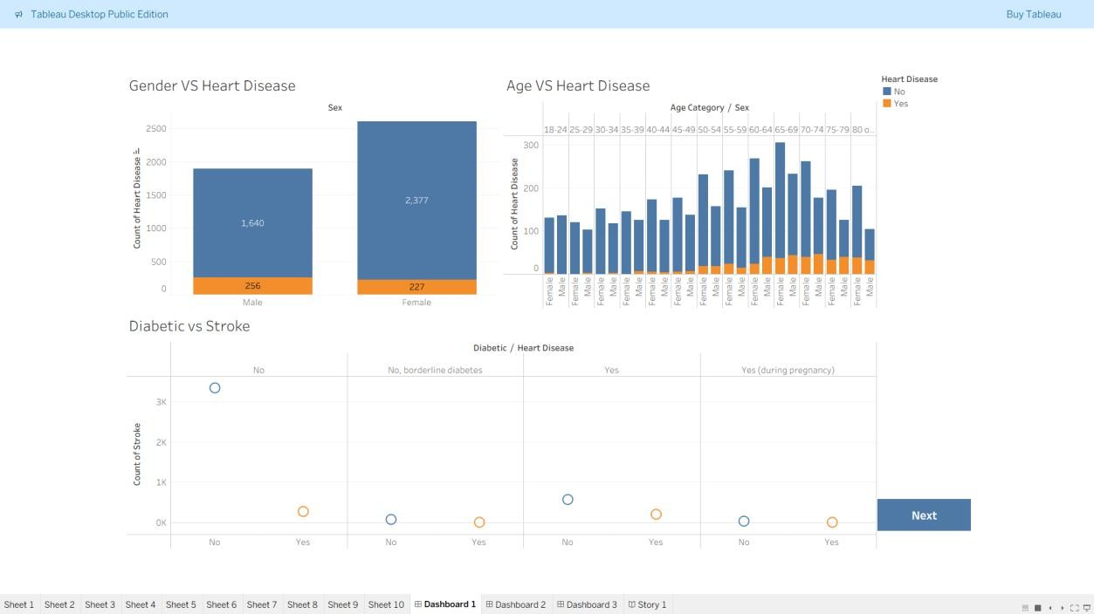

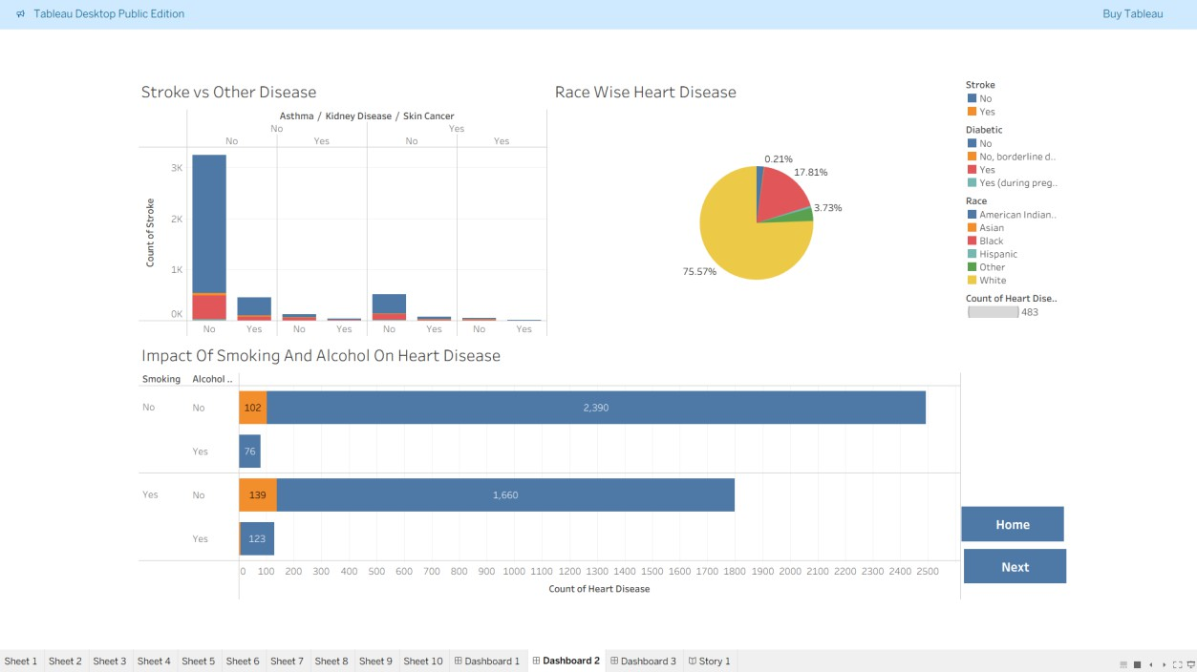

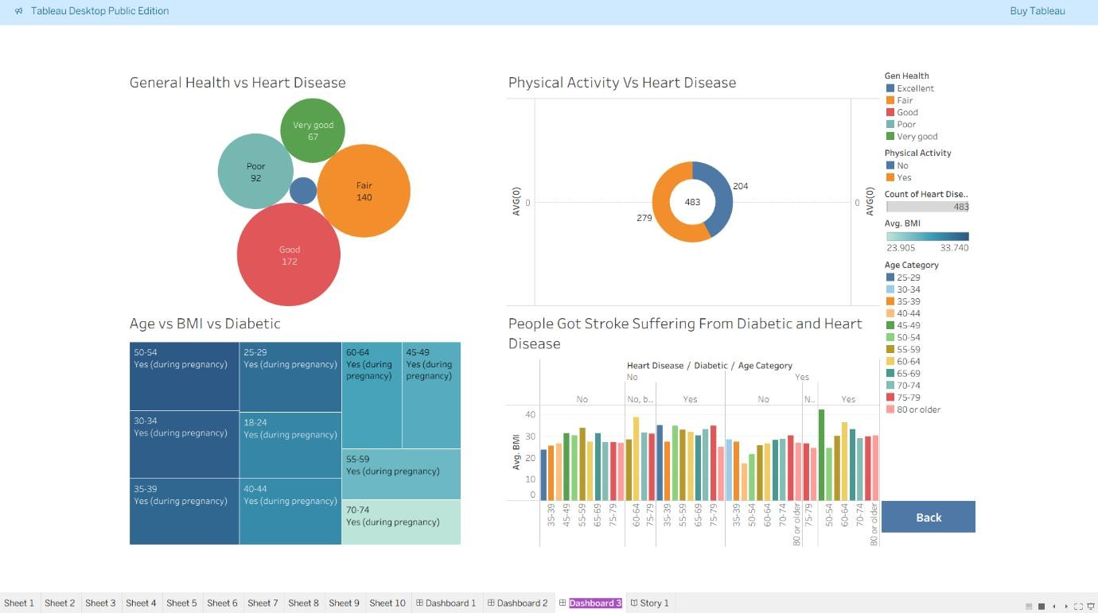

Story

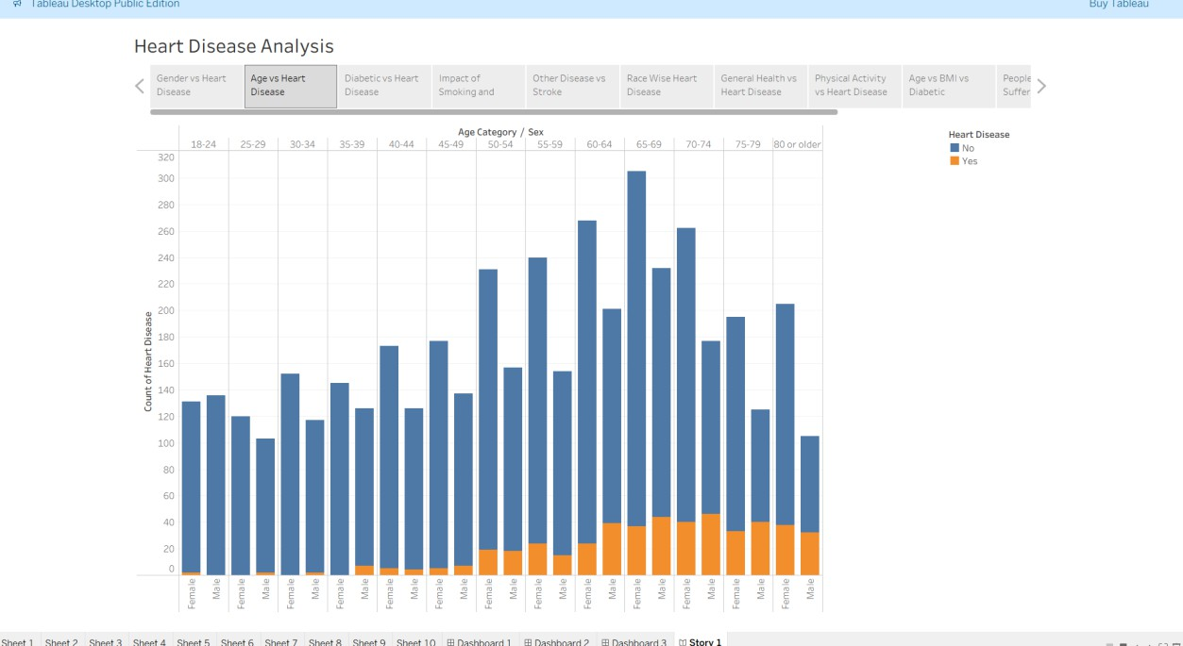

Web Integration

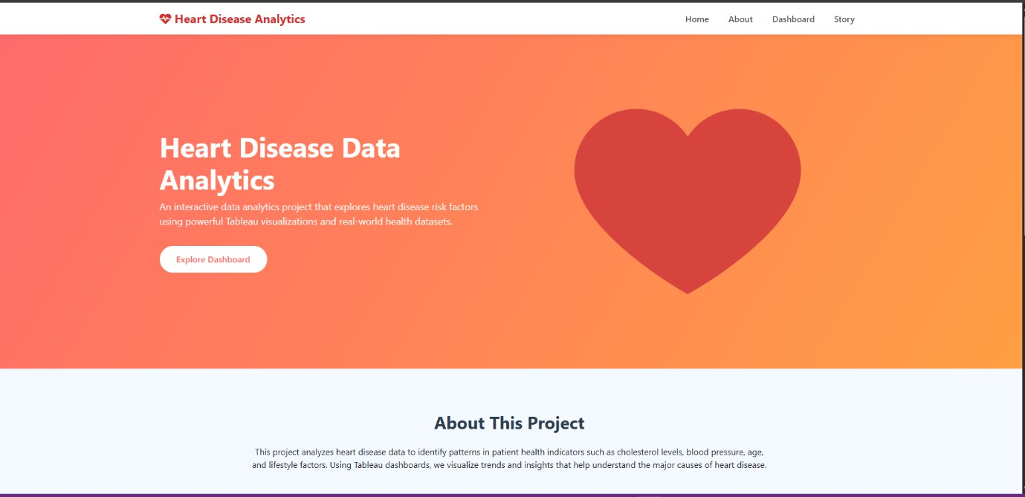

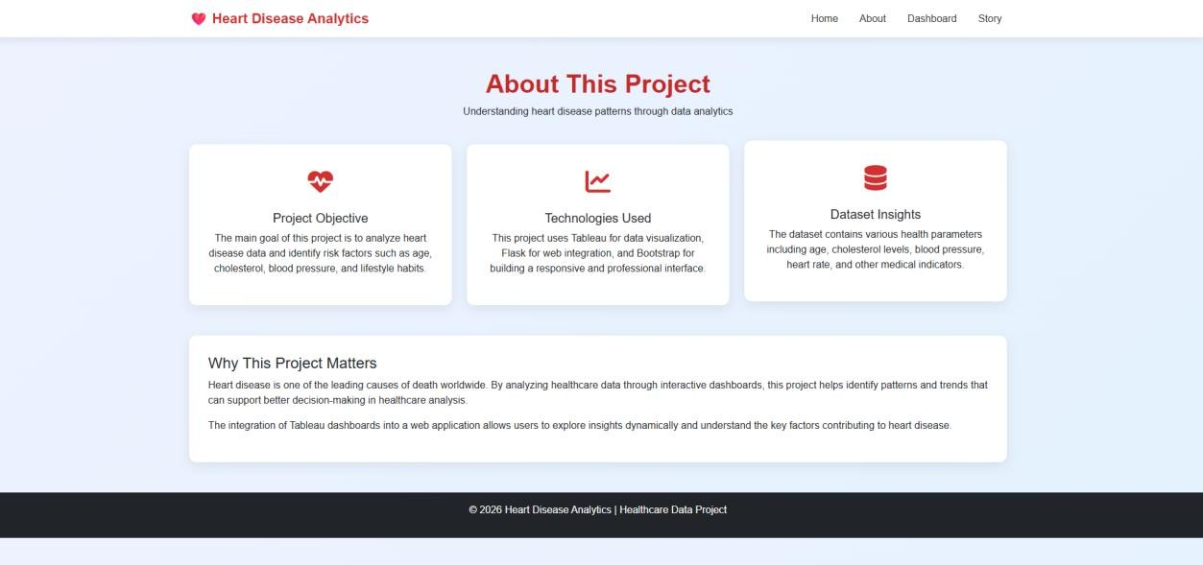

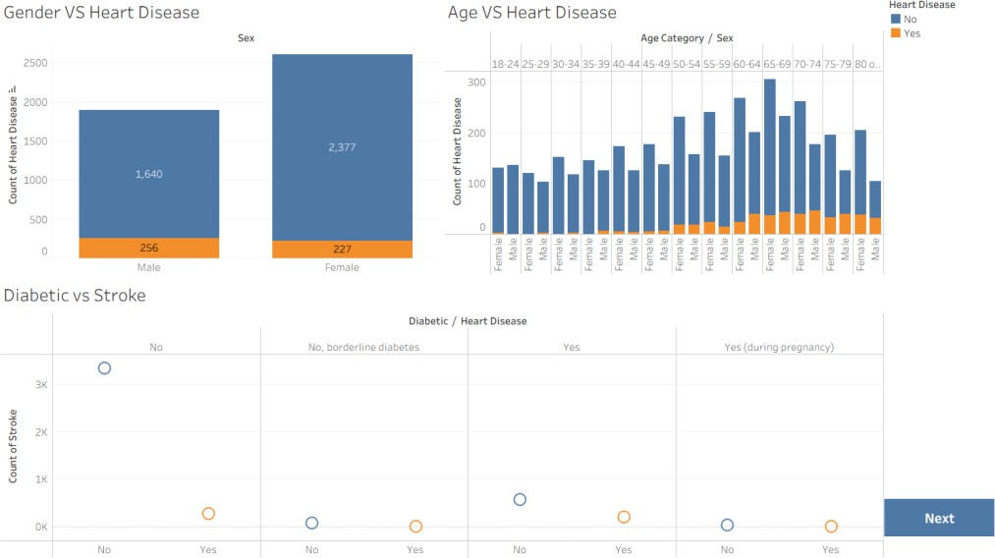

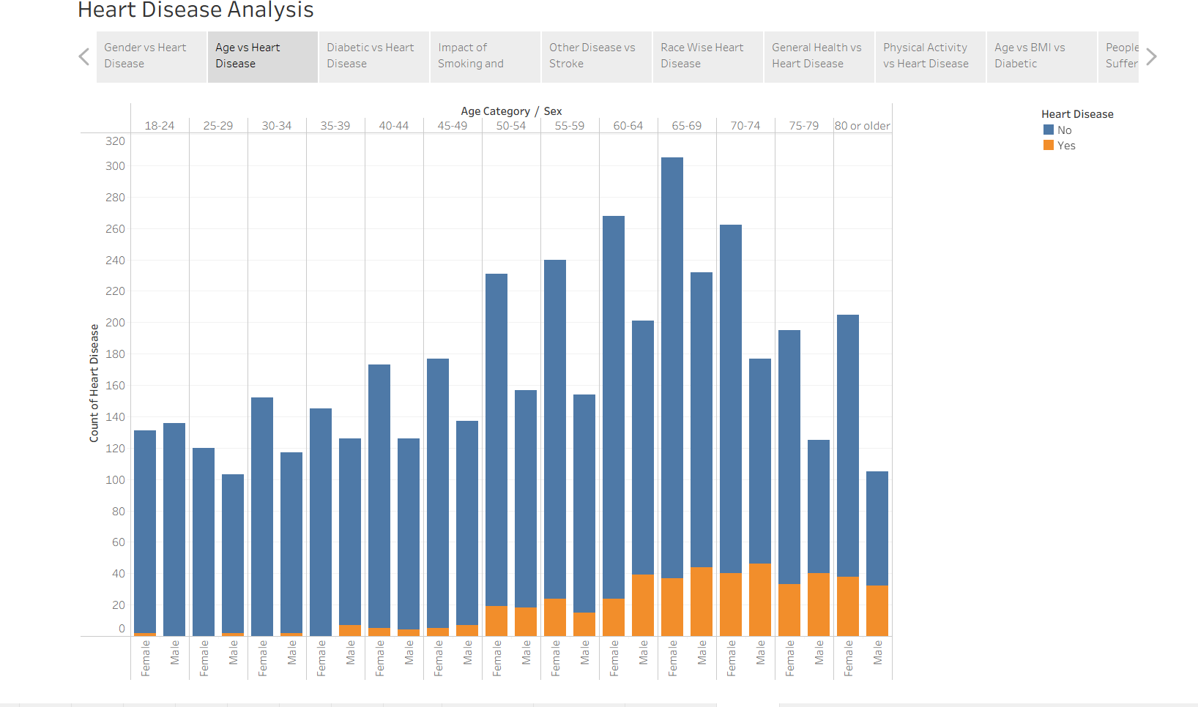

LINKS

GitHub Link :
https://github.com/pranav-chavare/HeartDiseaseAnalysis.git

Render Using Live App Link :
https://heart-dieaseas-tableau-3.onrender.com

VS code Terminal Link Run With Python:
http://127.0.0.1:5000

